Laser Dental Innovations
www.lazerdental.net
877-753-5054

Installing the StarLite Fiber Optic on your Diodent 2 Laser

- Unscrew the fiber connector from the front of the unit (you can cut off the connector if you want)
- Wind any remaining fiber from the other end onto the reel so it is out of the way
- There are now 3 choices to manage the new fiber:
  - Attach the fiber hanging clip (not shown) to the center of the existing fiber spool mounting it as high as possible
  - Wrap the fiber lightly around the existing spool
  - Remove the spool and mount the clip to the side of the laser as high as possible
- When the Starlite fiber is not in use coil it to at least a 6 inch diameter and hang from the
hook
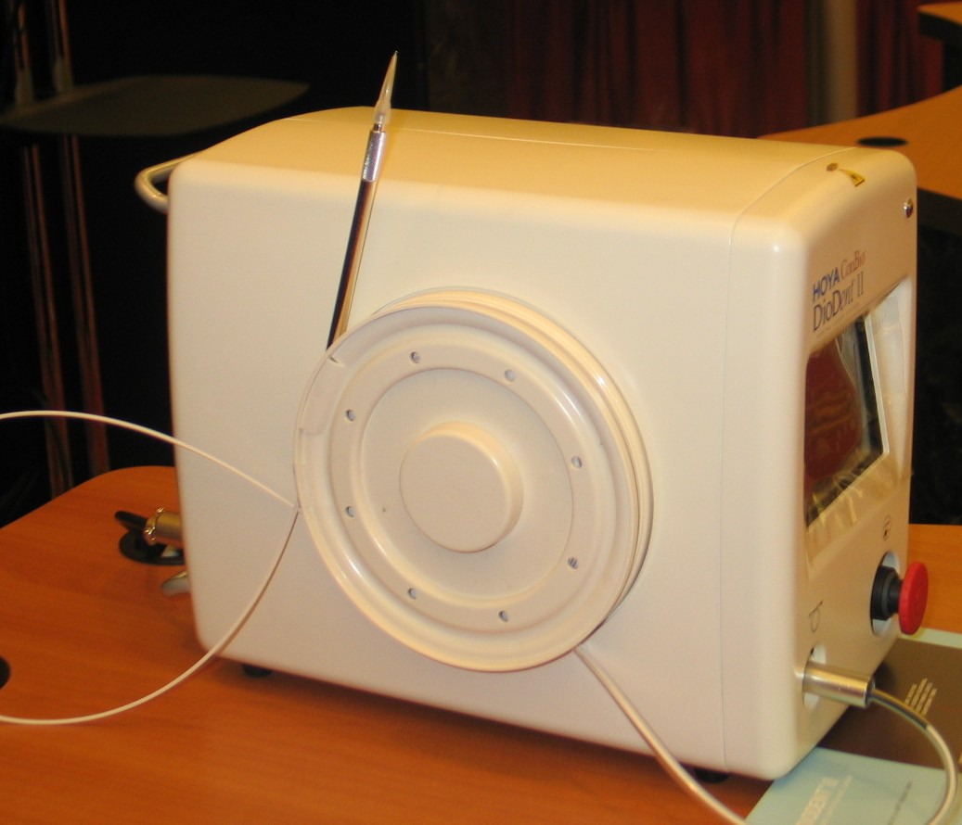

1
2
3a
3b
3c

