LASER DENTAL INNOVATIONS

StarLite Fiber Strip Instructions

This instruction sheet will assist in learning the proper strip technique for your new fiber optic. A little bit of practice and patience will result in a perfect technique and save you $150.00 on every order.

Stripping 300 micron fiber:

1. Holding the strippers make sure the blade inserts are orange in color and the top white ring says .031. If either of these is different the 300 micron fiber will not strip properly. Stop and call us

2. The fiber has a protective plastic coating over the glass fiber and must be removed. Insert the fiber into the top of the strippers 5-7 mm (This is the optimum stripping length for each cut) see figure 1.

3. Squeeze the handles closed and using your other hand pull the fiber out of the strippers. One quick pull works well and remember 5-7 mm max for each strip. Shake the strippers to assure the plastic casing that was just cut falls out.

4. Continue to strip until 25 mm of glass is exposed. This is the optimum length that works well for cleaving you can strip more if you desire.
Pull Stripped Fiber here
Insert 5- 7 mm of Fiber Here
Fiber Stripper Length Gage

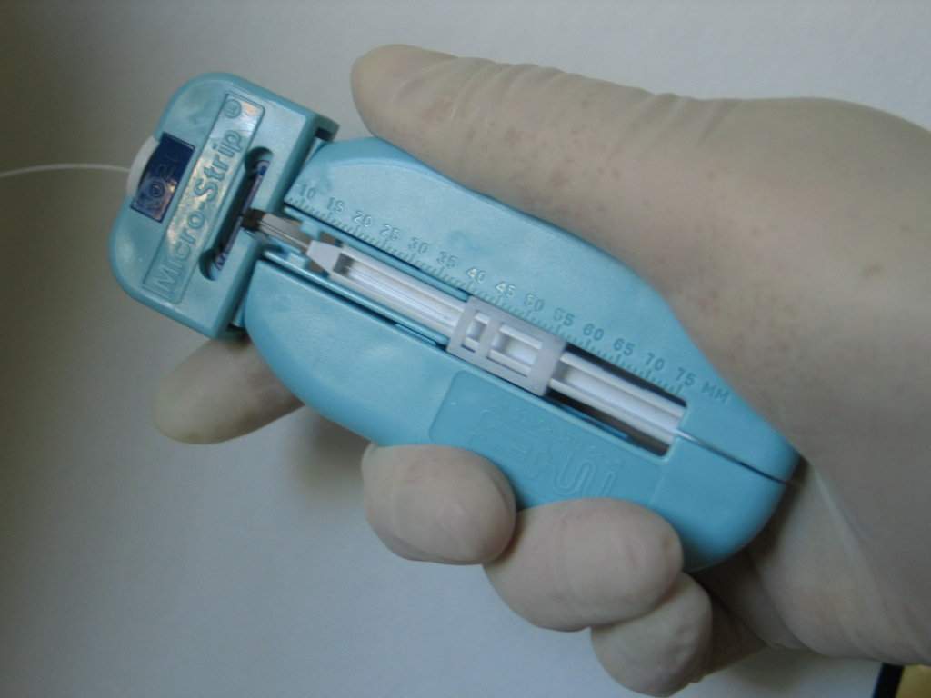
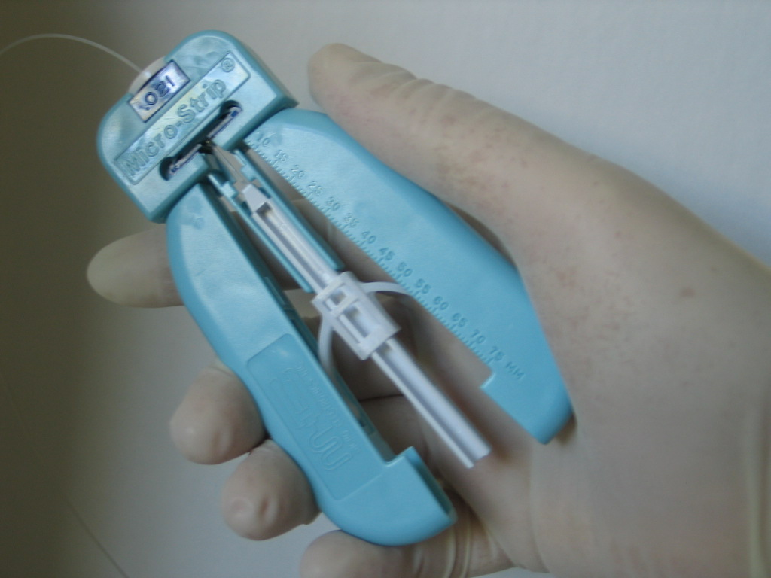

Figure 1:

Cleaver Tip

