LASER DENTAL INNOVATIONS

StarLite Gold Fiber Strip Instructions

Stripping Gold 300 or 400 micron fiber:

1. Holding the strippers make sure the blade inserts are Maroon in color and say .023.

The fiber has a silicone rubber jacket over the glass fiber and must be removed. Insert the fiber into the top of the strippers 20 mm

3. Squeeze the handles closed and using your other hand pull the fiber out of the strippers. Shake the strippers to assure the casing that was just cut falls out. If it sticks in the white channel this can be slid out and the jacket removed.
Insert 20mm of jacket and fiberFiber Here
Pull Stripped Fiber here
Fiber Stripper Length Gage

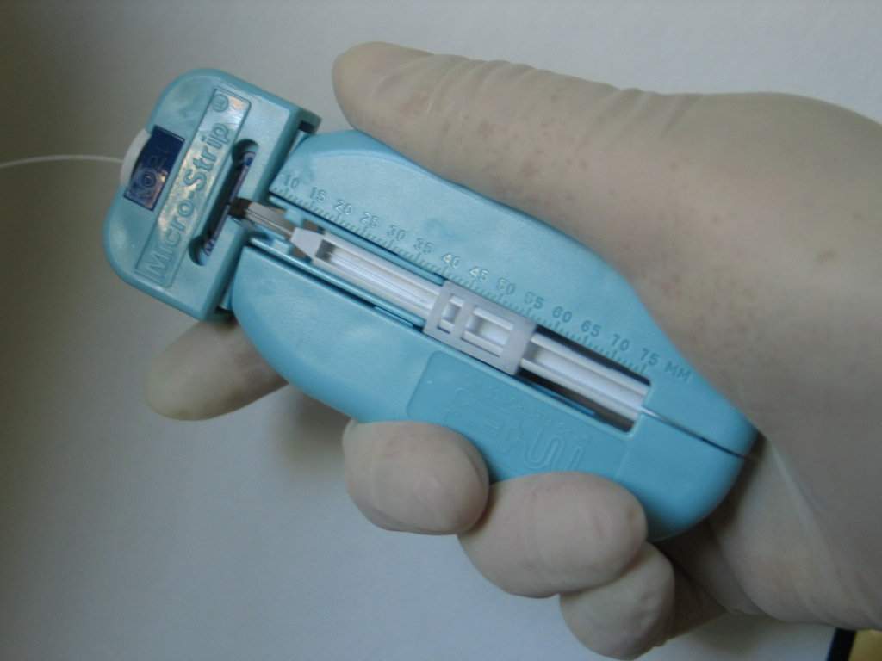
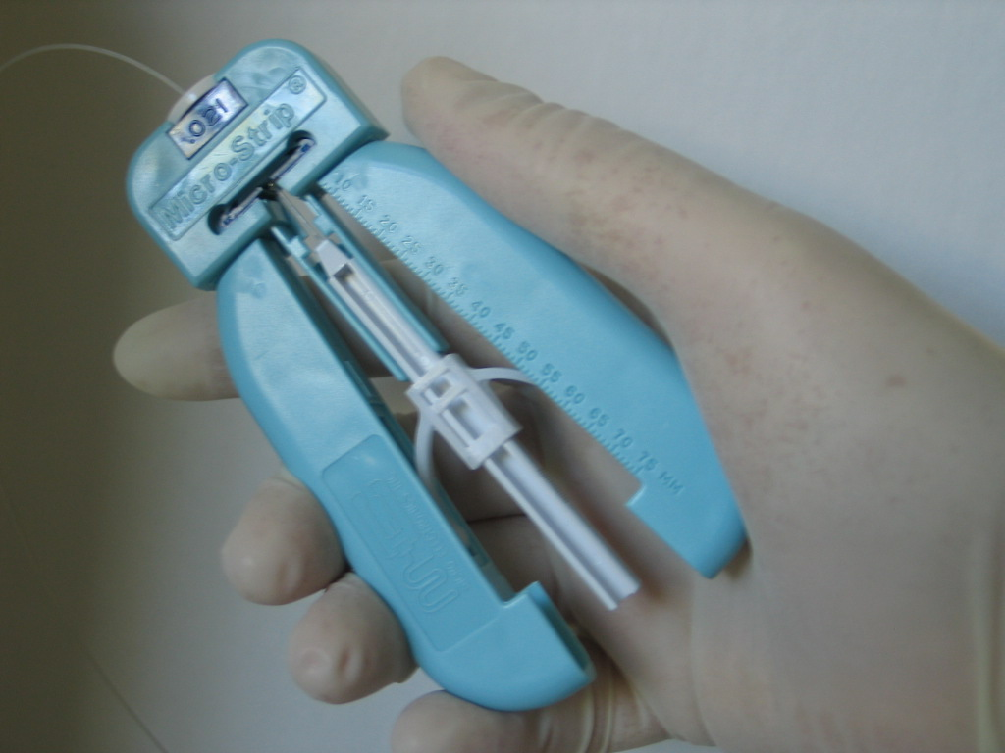

Figure 1:

Cleaver Tip

