Laser Dental Innovations
Setting up the LiteSaber Handpiece with the Starlite Fiber Hard Clad

1. Insert the unstripped fiber into the strippers as shown in figure A and remove about 8 mm with each strip until 3/4 inch of the protective fiber coating is removed as shown in figure B.

2. Cleave ¼ inch from the exposed fiber core as shown in figure B.

3. Insert the fiber into the LiteSaber handpiece but do not tighten the cap as shown in figure C. Slide the fiber thru the handpiece until the fiber just exits the front of the handpiece as shown in figure D .

4. Position a laser glow tip on the front of the handpiece as shown in figure E.

5. Straighten the tip to assist in sliding the fiber thru the tip until 3 mm of stripped glass core is protruding.

6. Tighten the rear cap until the fiber does not slide. Bend the tip to the desired angle.

7. When the handpiece gets close to the outer fiber winding jacket figure F simply slip the large outer jacket off the fiber about 2 feet and remove 8 inches of jacket with scissors then slide back on.
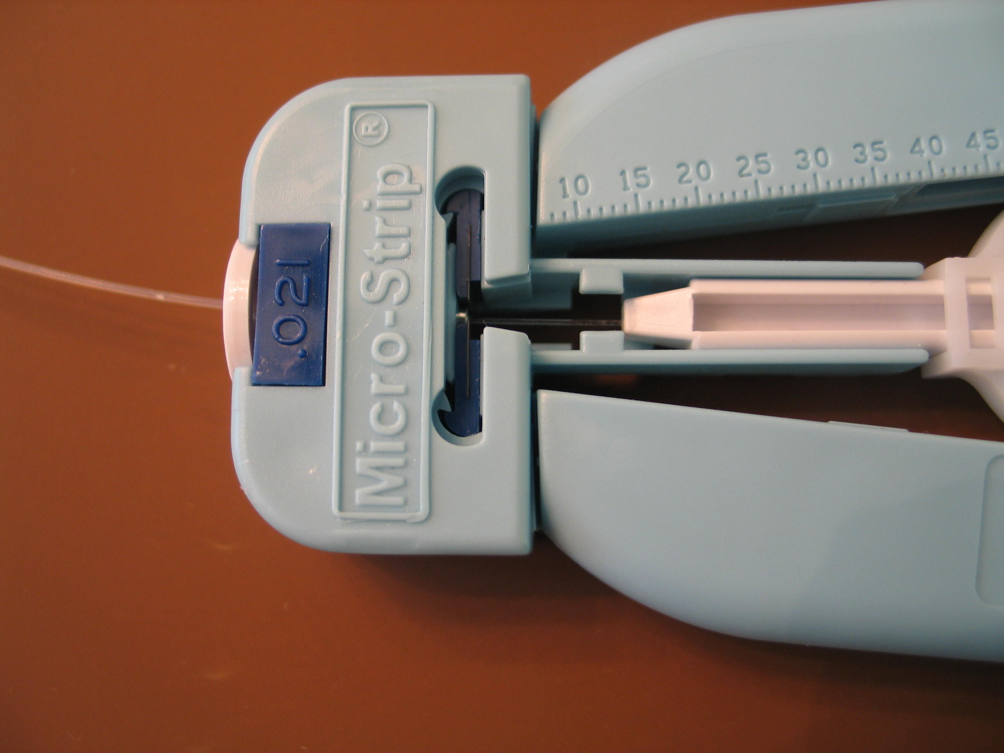
1 Inch Strip
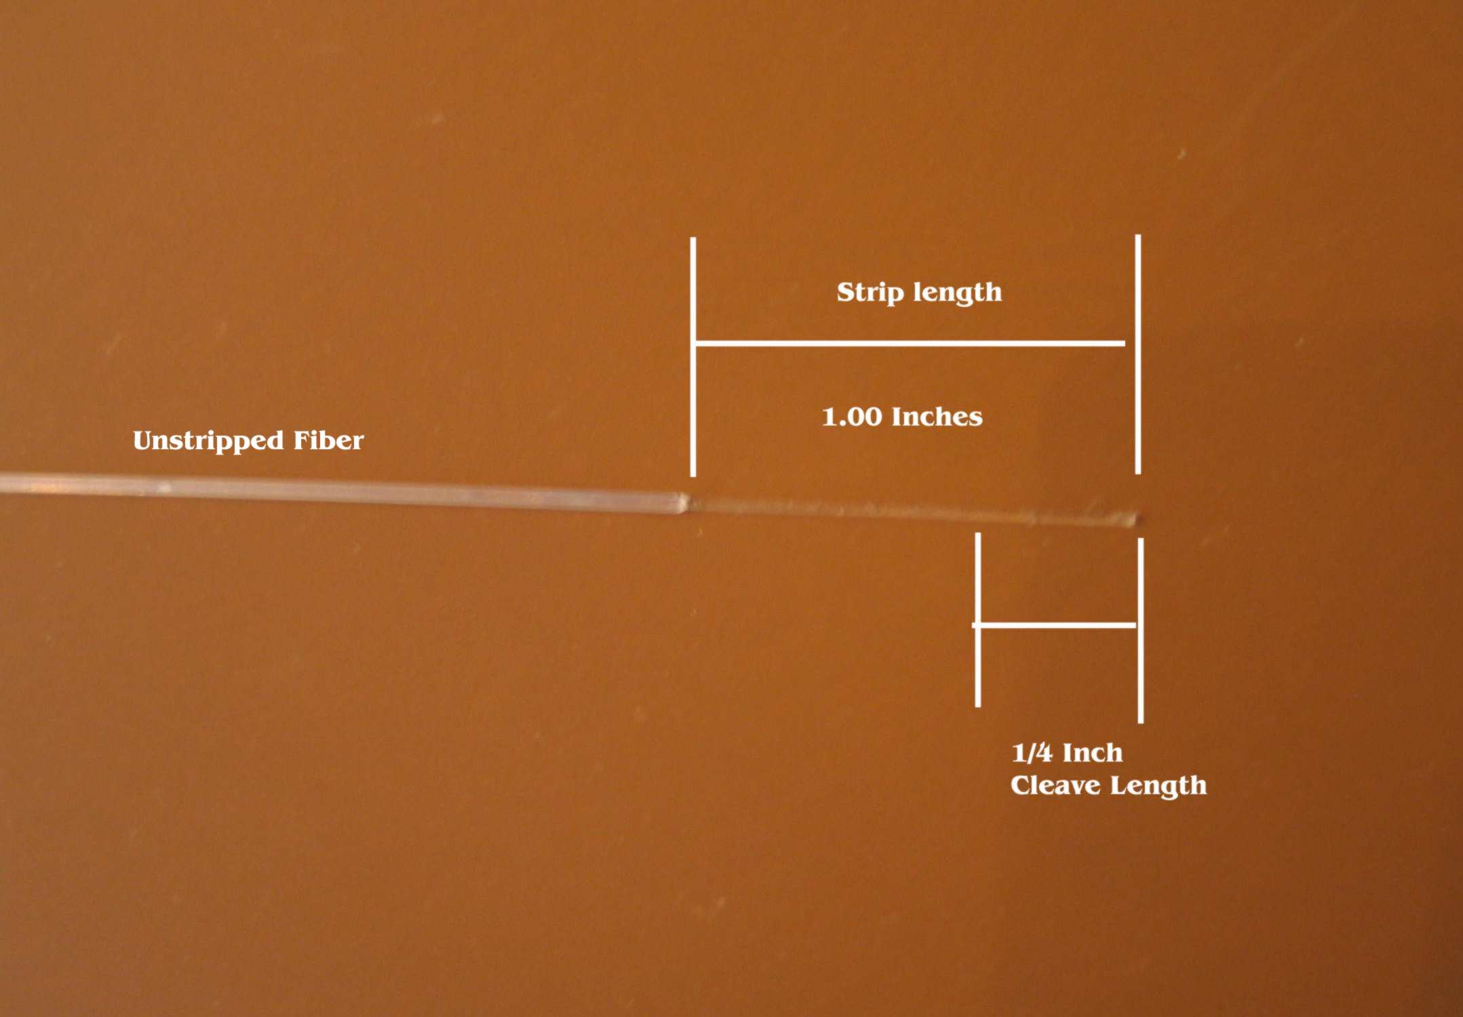
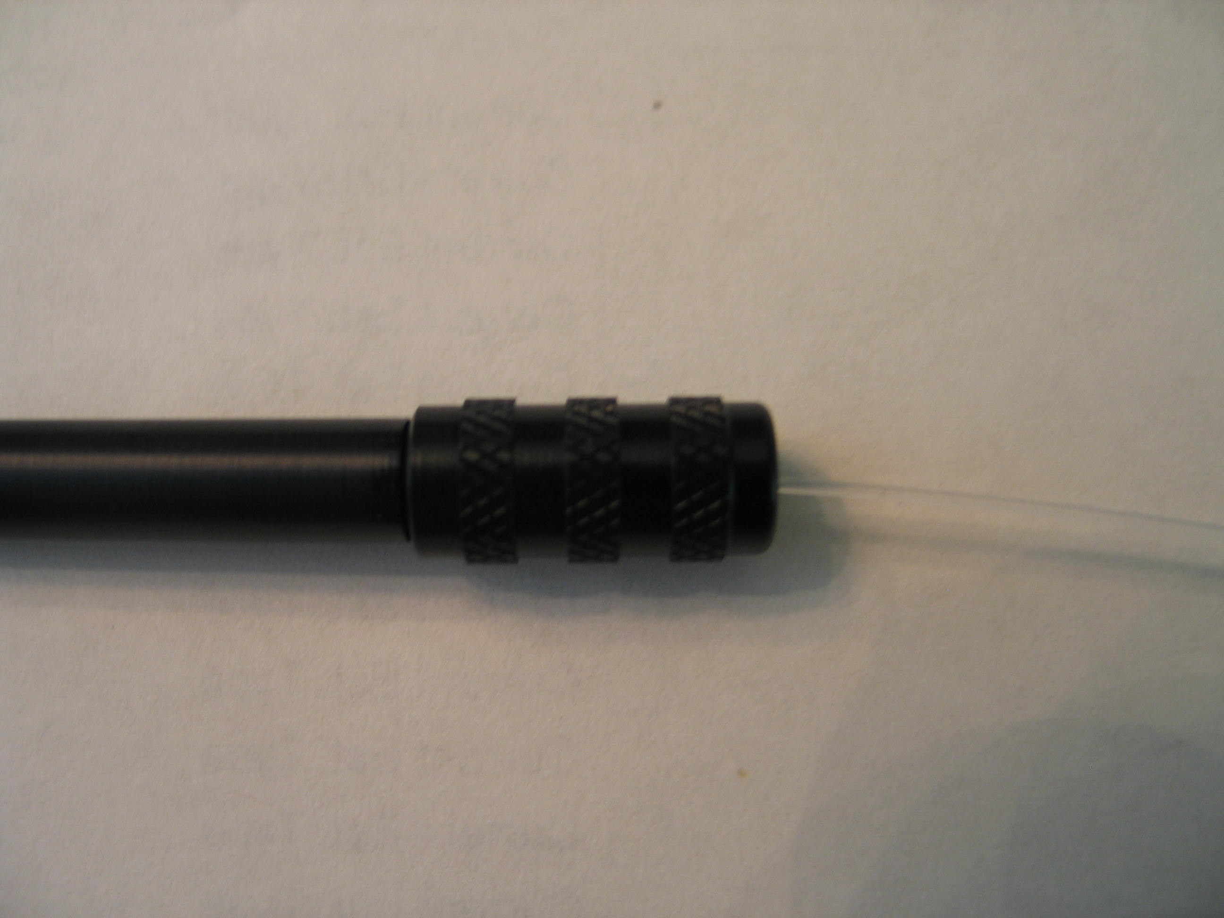
Figure A Figure B Figure C
¼ inch cleave
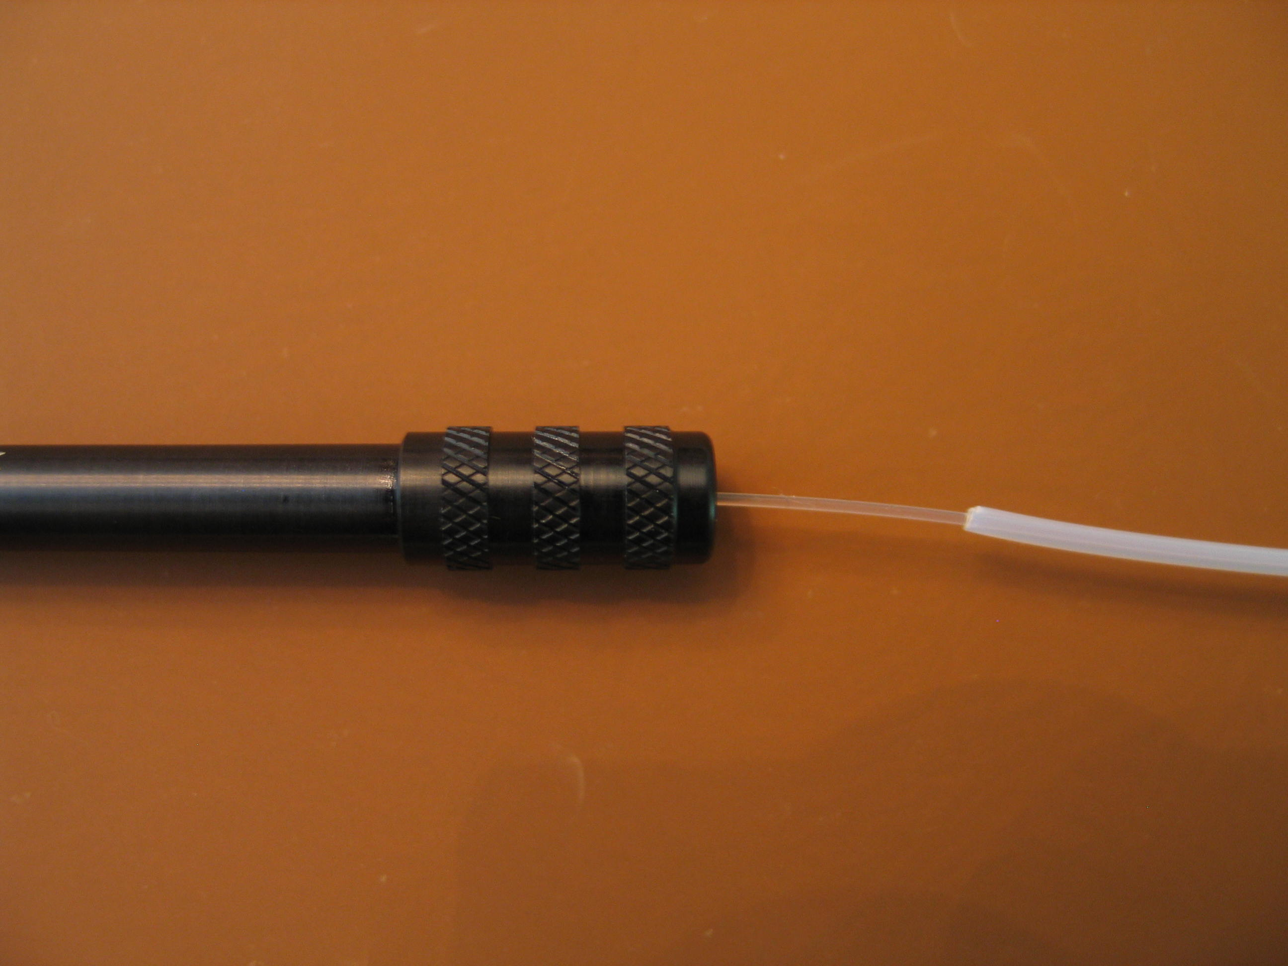
Figure D Figure E Figure F
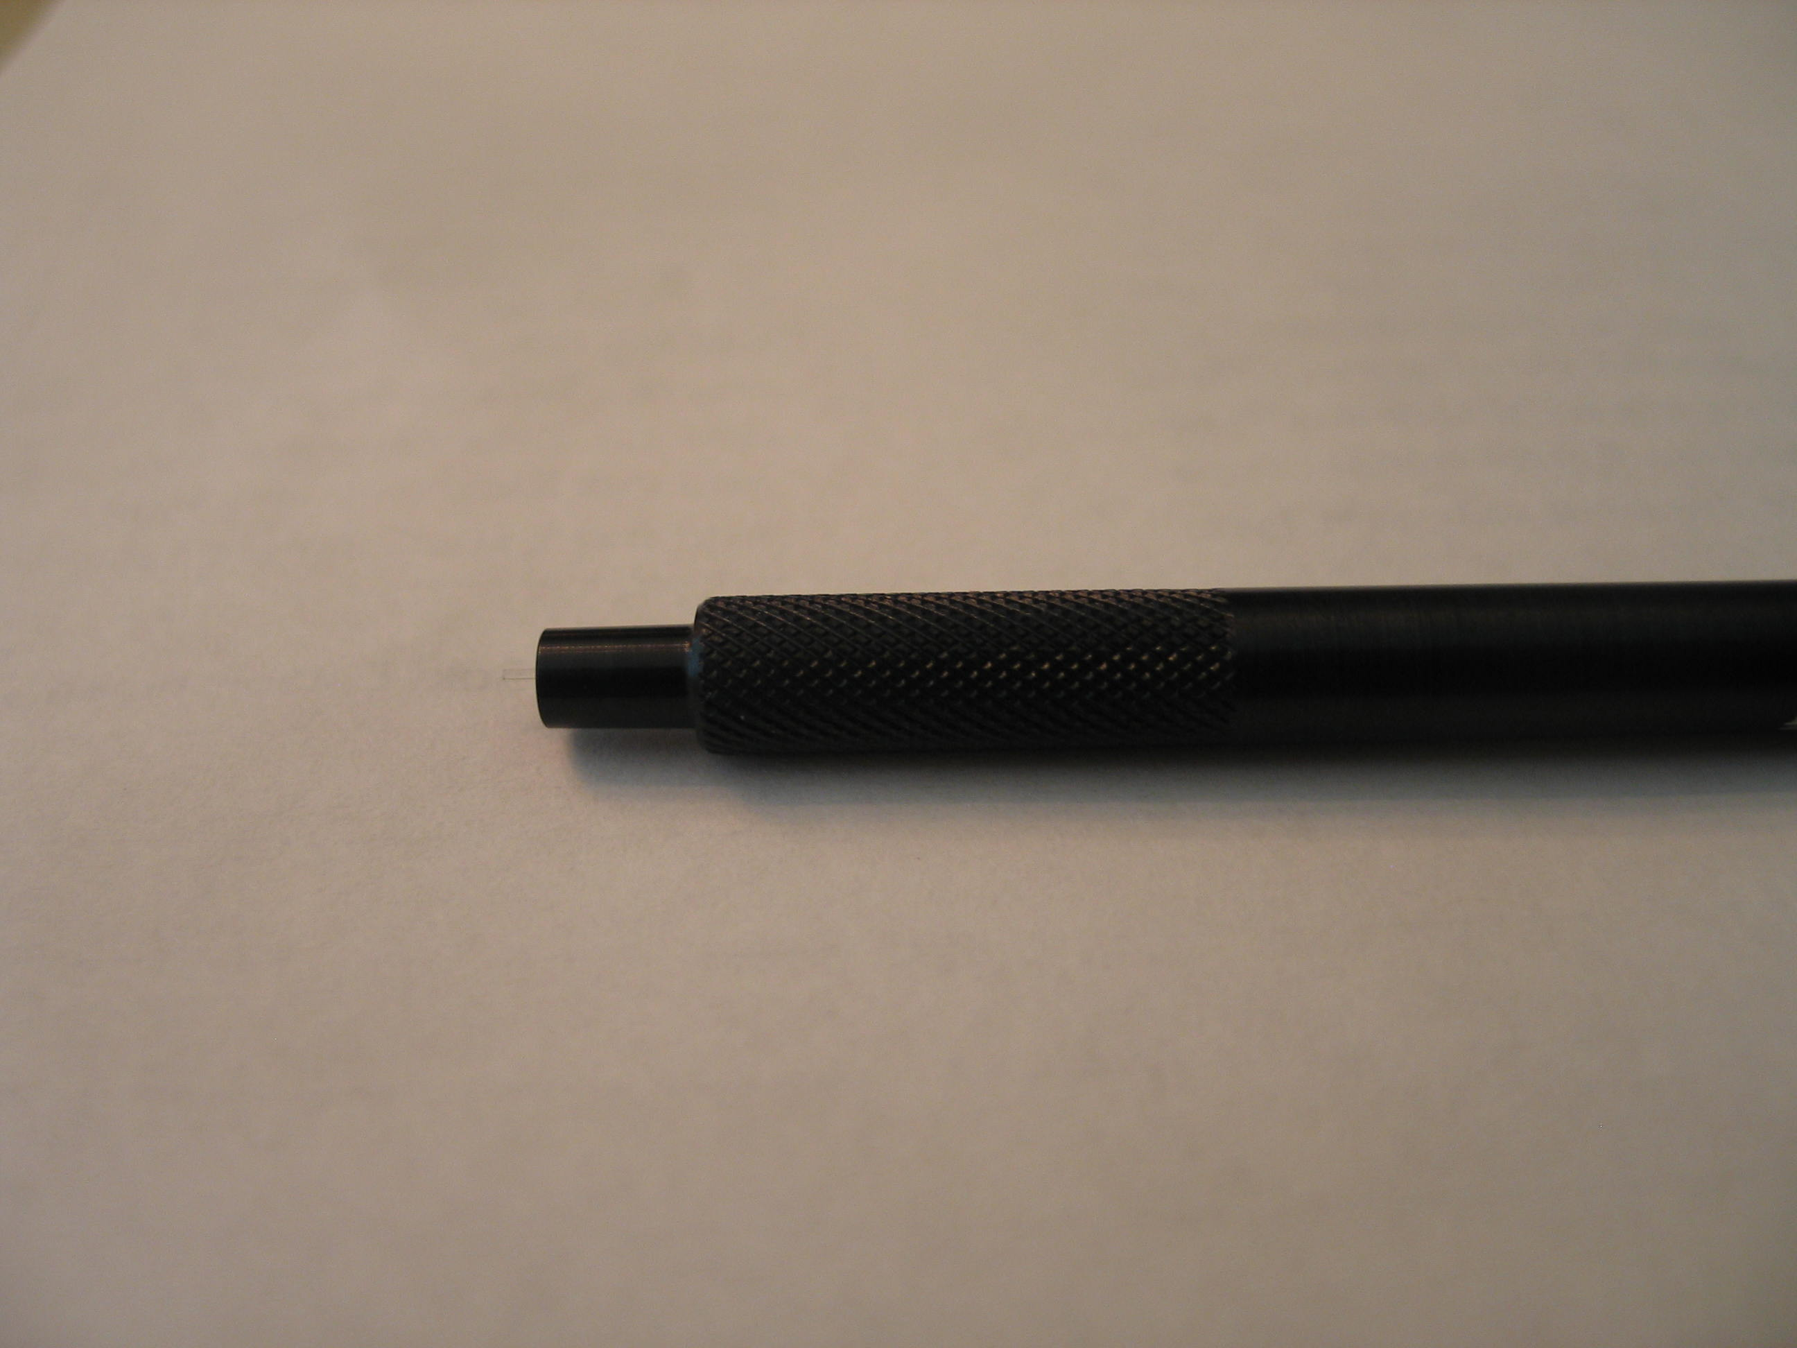
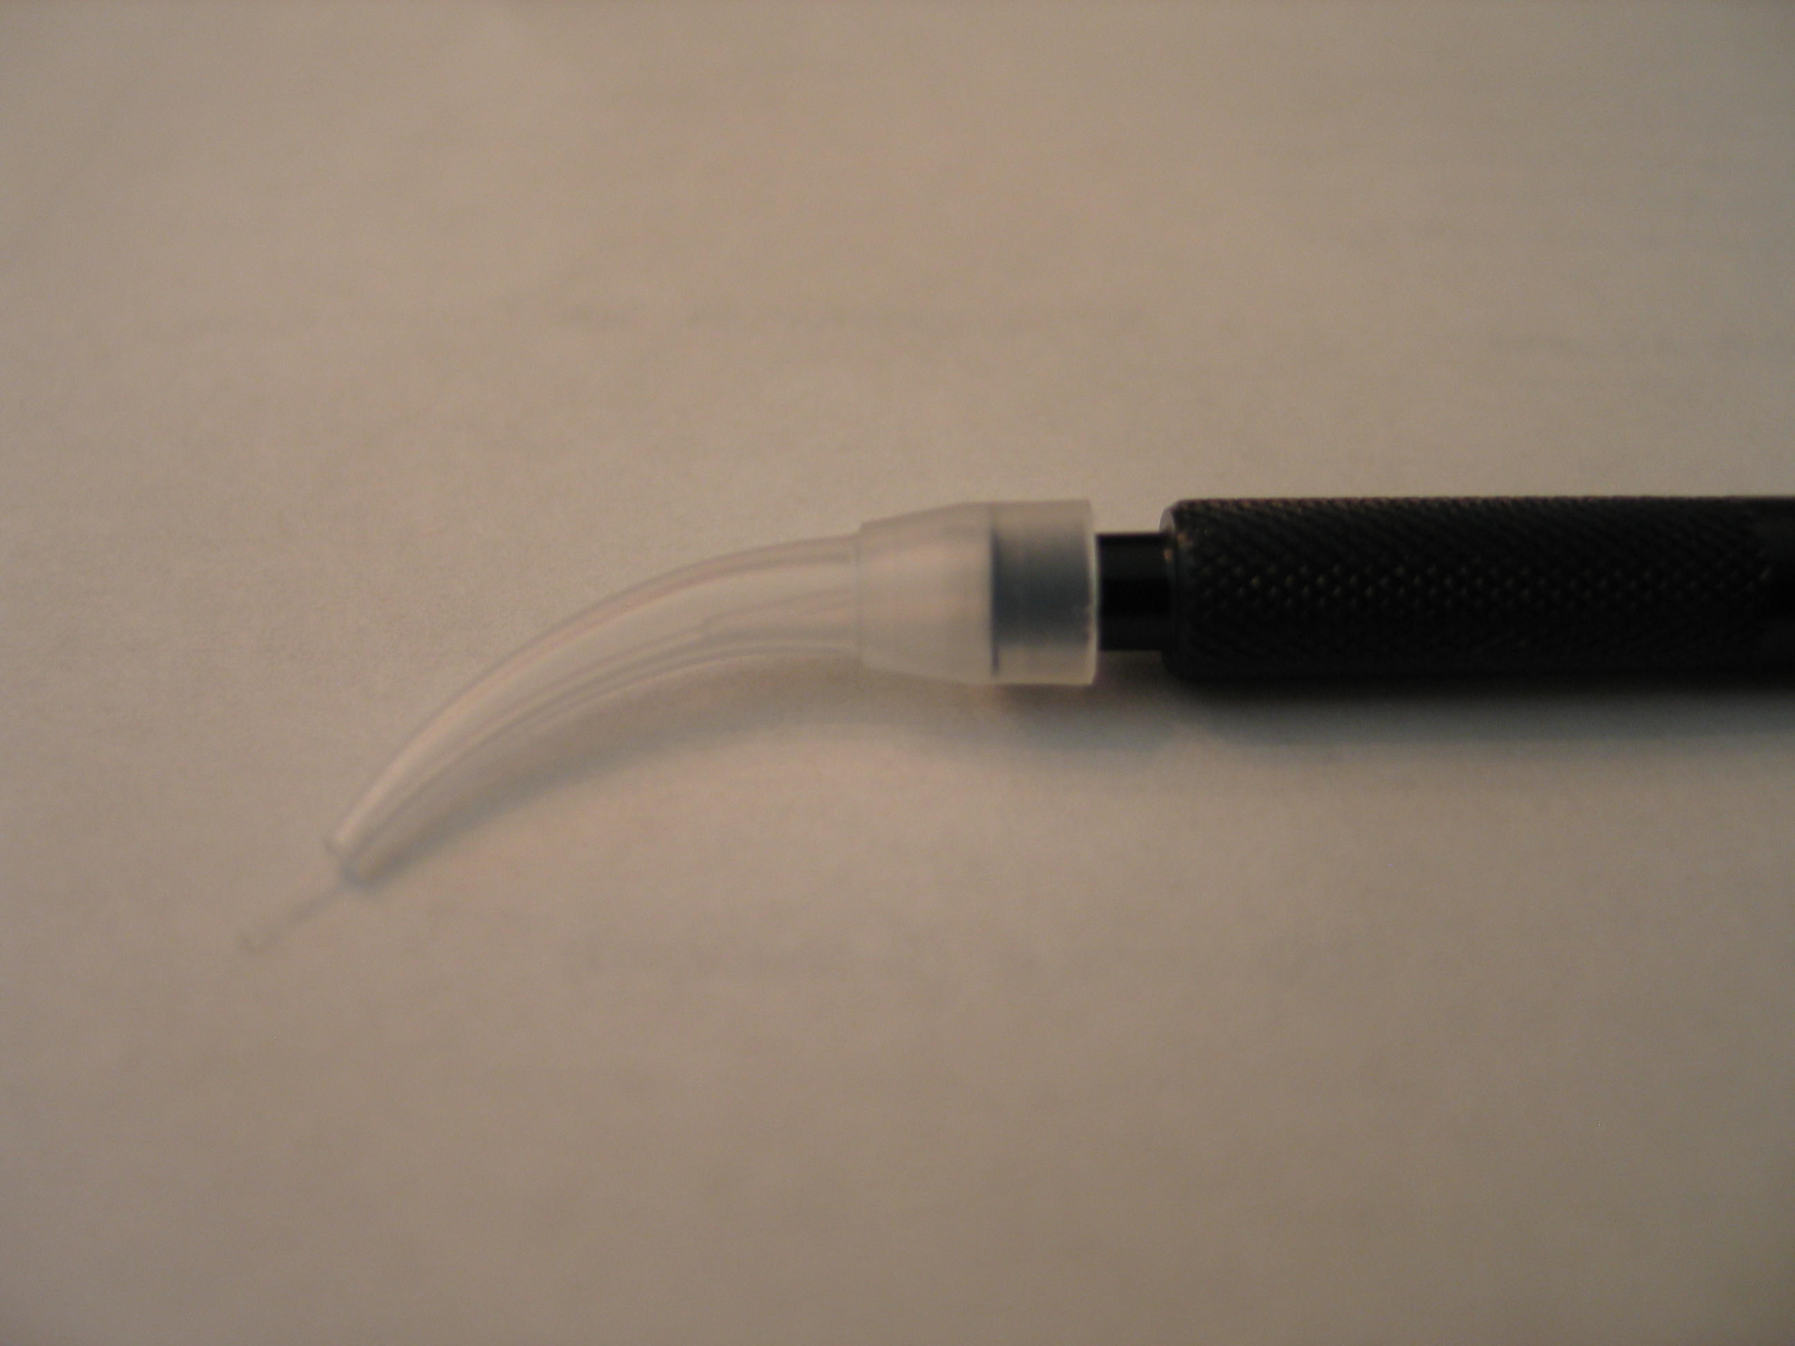
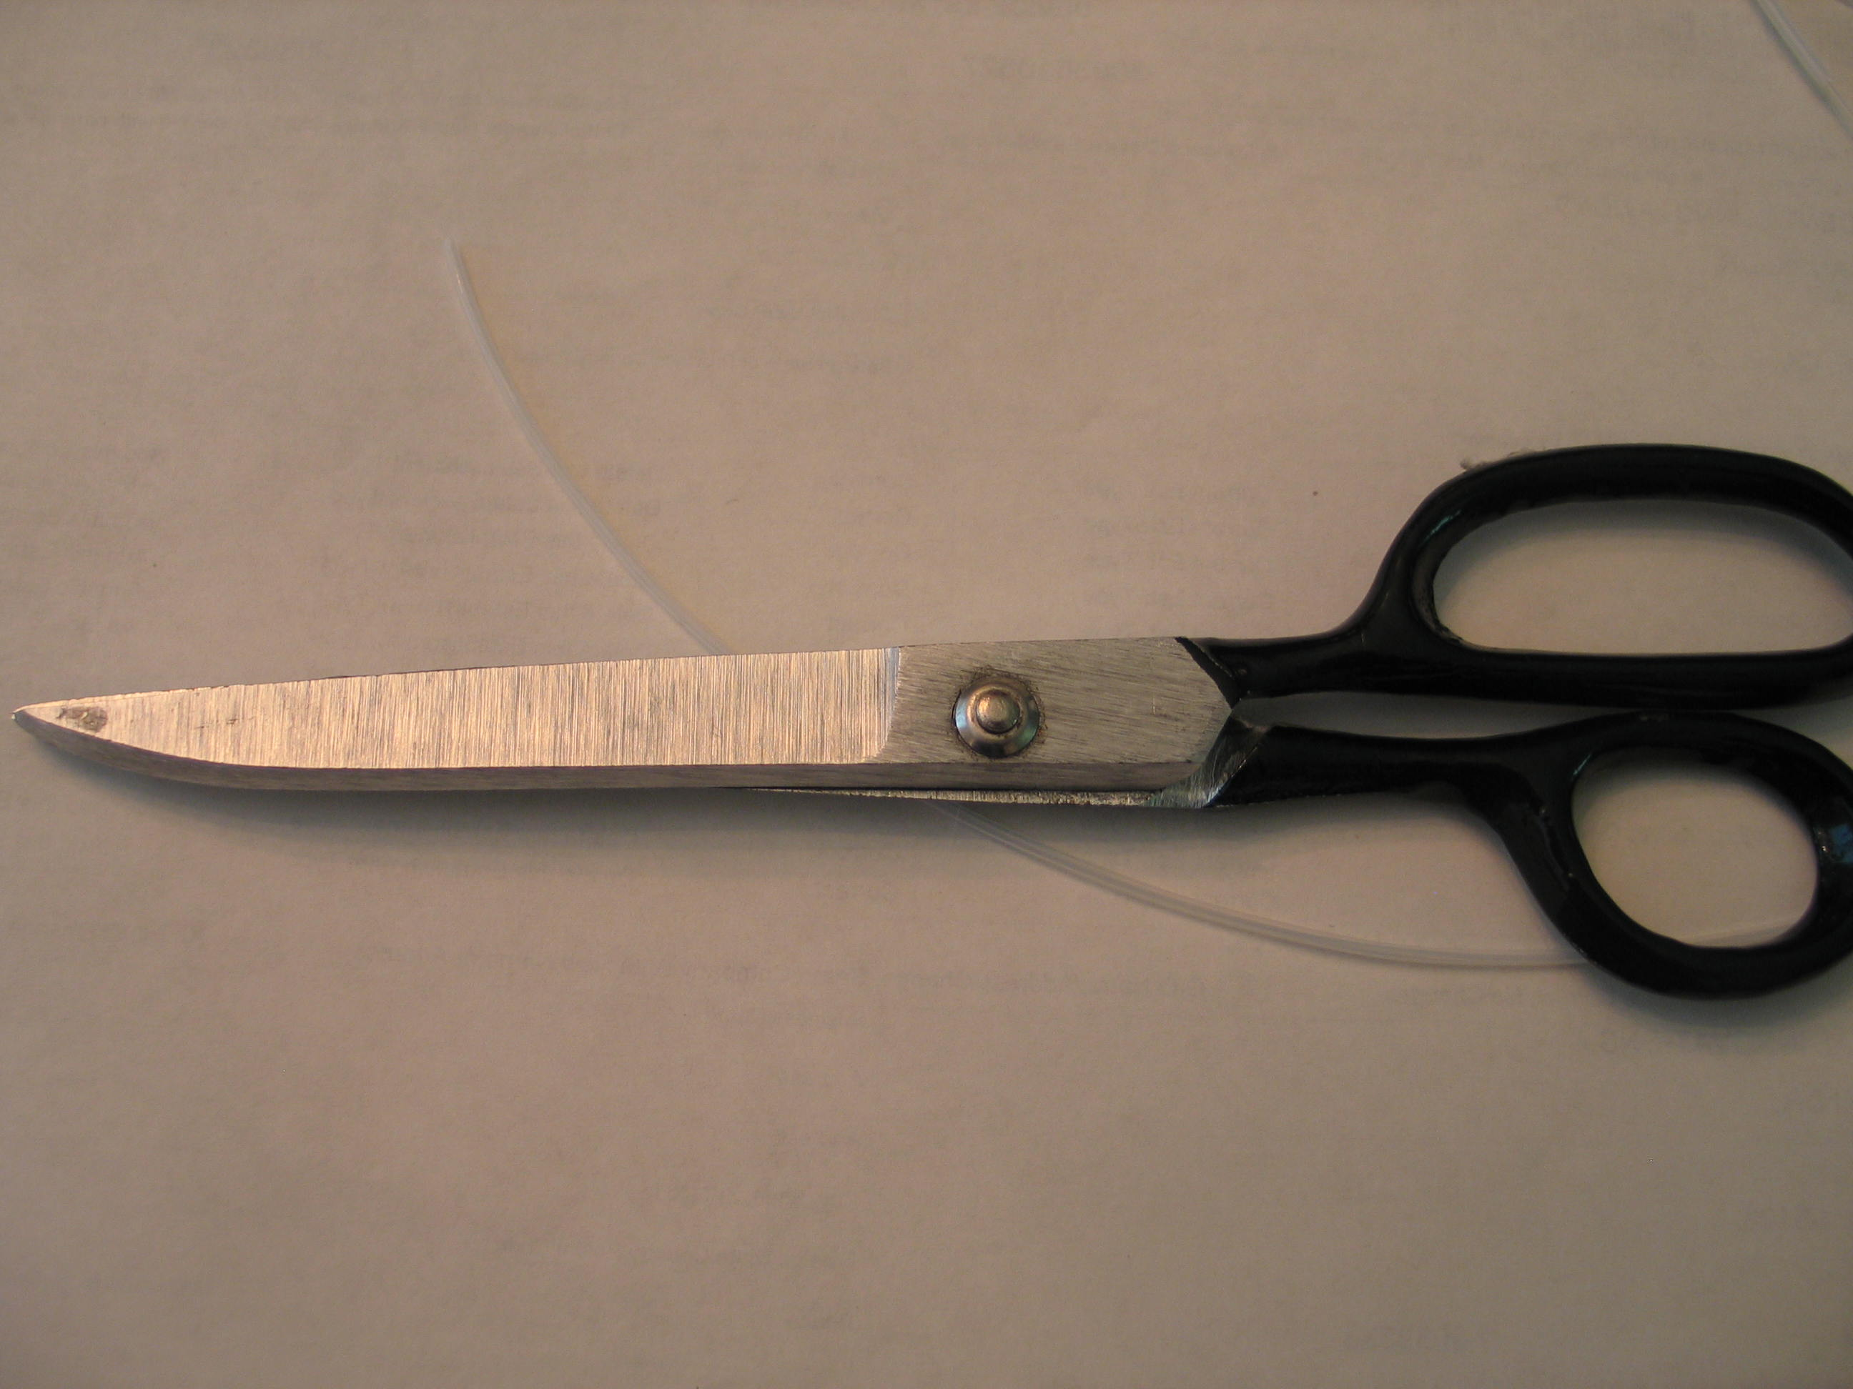
Figure F

