LASER DENTAL INNOVATIONS

Exclusive Supplier of the only Bendable Cannula for Laser Dentistry that retains

the angle you set

877-753-5054 to reorder

LD65-T or C Surgical and Hygiene Dental Laser Disposable Tip User Instructions

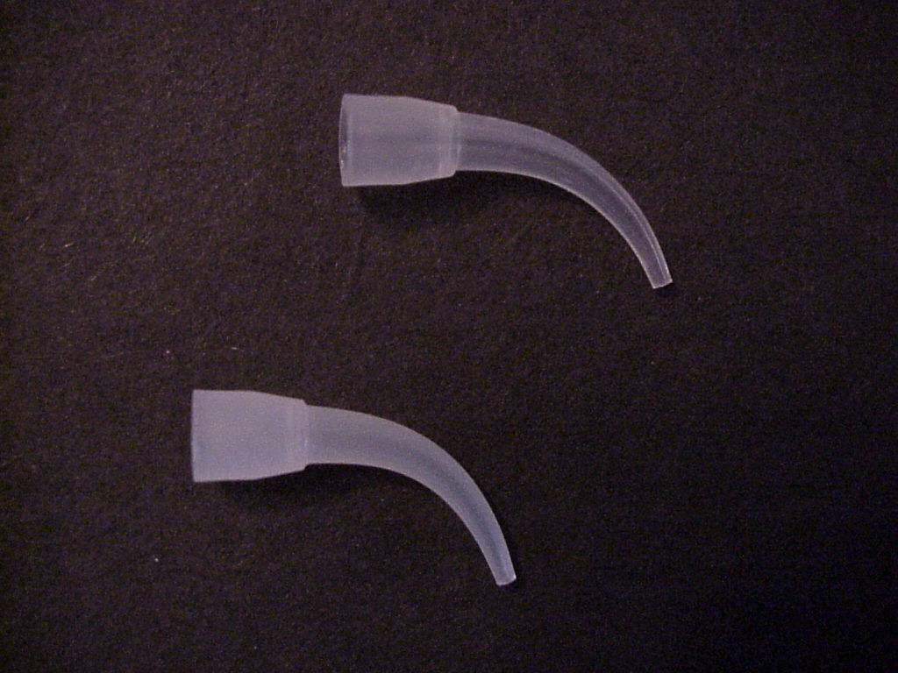

Tips are packaged in a sealed plastic box
Assure paper seal is intact

Inspection of the tips after unpacking:
- Visually inspect the box for any signs of damage
- Tips comes un-sterilized and need to be cold sterilized before each use

Caution: Use Non-Flammable Sterilization Fluid only.
Tips are disposable and not FDA approved for multiple use. After use do not re-cold sterilize or autoclave, Please Discard !

Loading the tips onto the LiteSaber series handpieces
- Push large end of tip onto handpiece taper until tight
- Straighten tip slightly and feed fiber thru then let tip bend back to its natural position.
- Bend to desired angle

