Laser Dental Innovations

Fiber Optic Cleaver

User Instructions:

Sterilize before use unit comes not sterile.

This is a Precision Engineered Fiber Optic Cleaver please read all instructions for best results
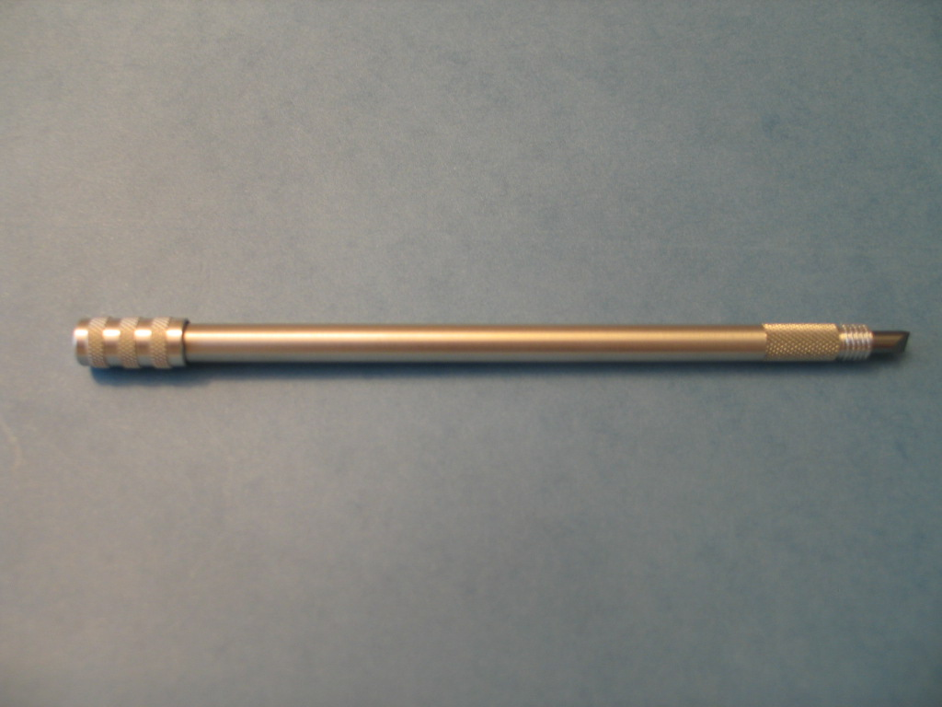
Cleaver Protective Cap
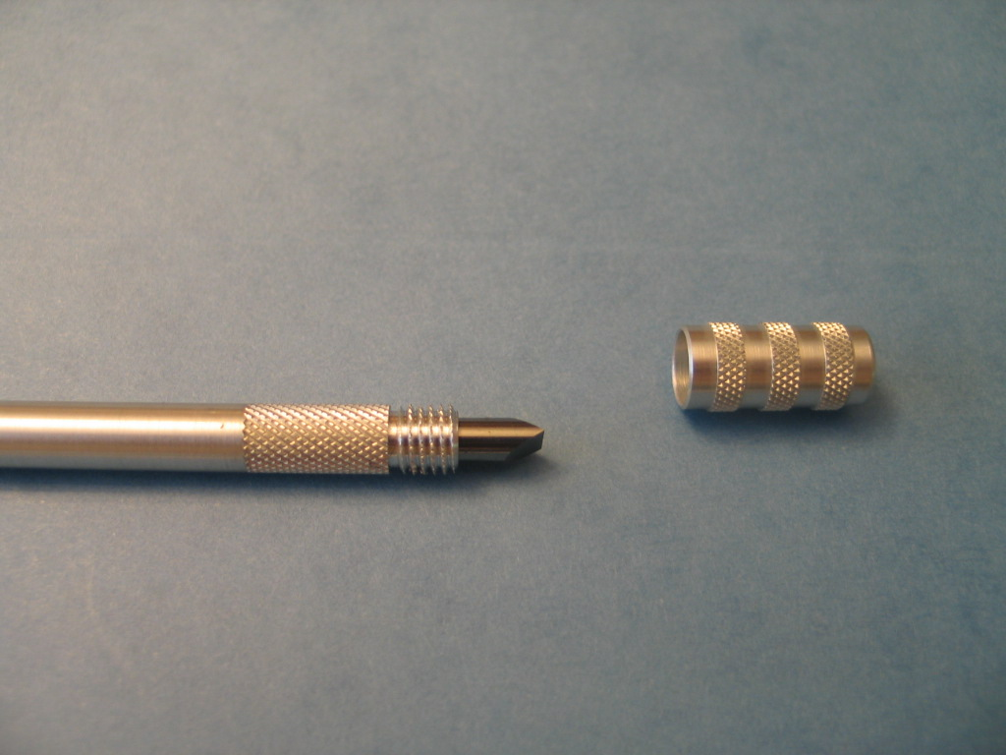
Cleaver Body
Cleaver Tip

Using your new Cleaver:

Caution: Be careful to not hit the cutting edge of the cleaver on any hard surface as this may damage the blade.

- Sterilize the Cleaver body assembly and cap before use. (See sterilization instructions)
- Unscrew the cap from the cleaver to expose the cutting edge.
- Screw the cap onto the rear thread for storage.
- Score the fiber by holding the cleaver perpendicular (90 degrees) to the fiber using light pressure.
- When fiber cleaving is complete move cap from rear of cleaver to front to protect the tip. Be careful to only screw cap on enough to protect tip do not over tighten or blade damage may occur.

Following the below procedure will result in a sterilization assurance level of 10⁻⁶ as verified by Northview Labs of Illinois

- Scrub the external cleaver body, cap and their threads with the brush, to assure no debris remains flush with generous amounts of warm clean running water.
- Avoid Ultrasonic Cleaning which may damage the Cleaver coating

Autoclave Preparation
- After rinsing
- Put Cleaver in a standard autoclave pouch
- Autoclave at 270 F for 30 minutes
- Cool for 20 minutes before handling

