Set Up Instructions for Opus 5 and 10 Laser Fibers:

Following this procedure will result in your fiber not slipping in the handpiece. Make sure the fiber you have is like the one shown below.

Step 1: Strip 10 inches of the white, yellow or black outer jacket from the fiber. (Be careful not to nick the inner plastic covering).
Hard inner plastic covering the core
Glass Core Strip 20 mm before cleaving
or 1.5 inches
Outer Jacket remove 8 inches as handpiece gets close
`

Handpiece Internal View
Put tip here

Step 2: Strip 20mm or 3/4 inches (remove 7-10 mm each time until you remove 20 mm of the inner plastic jacket using your 200, 300 or 400 micron strippers. Removing 7-10 mm at a time assures minimum cladding damage. This will also assure that the fiber length is correct for your 90 degree Laser Glow Tips and will greatly minimize breaking .

Step 3: Cleave the fiber back about 1/4 inch and assure you have a clean break.

Step 4: With the cap in place slip the fiber thru the handpiece as shown until the stripped end is just at the front end of the handpiece.
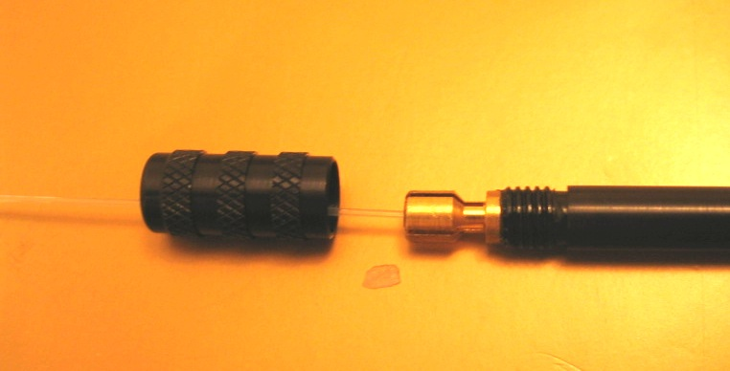

Step 5: Put a 90 degree tip on the handpiece. Straighten the tip which will greatly increase your success at fiber feeding and minimize breakage thru until the protrusion you require is exposed usually 3-5mm for most procedures.

Step 6: Rotate the cap until the fiber locks.

Step 7: Bend the tip to the required angle.

Step 8: When the handpiece gets close to the outer jacket simply remove the handpiece and slide the outer jacket off the inner fiber about 8-10 inches. Cut off the outer jacket being careful not to cut thru the inner plastic covering.

