LASER DENTAL INNOVATIONS

StarLite Fiber Optic for Sirona Laser

User Instructions:

Sterilize before use unit comes not sterile.

This is a Precision Engineered Fiber Optic Assembly please read all instructions for best results
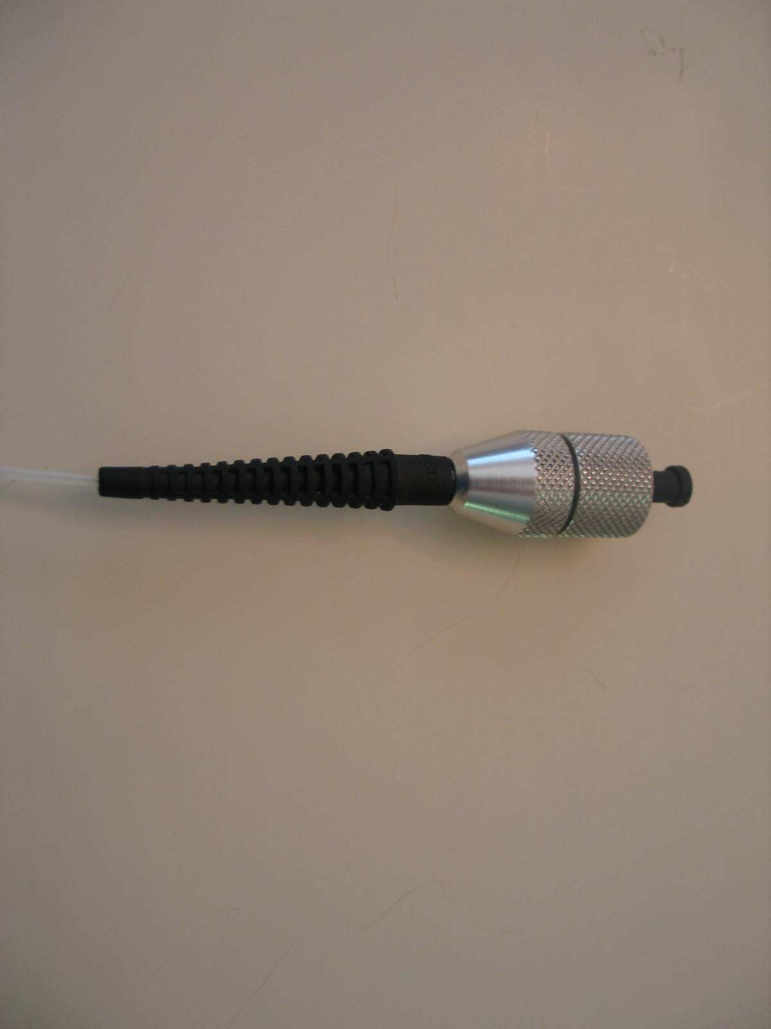
Laser Coupler

Fiber Strain
Relief
Protective
Cap

Using the Star Lite Fiber Optic:

Caution: Be careful to protect the front face of the optical ferrule at all times. Use protective cap when removed from the Laser. Distal end already has a tested good cleave for your convenience.
Cleaver Tip
- Sterilize the entire fiber optic assembly before use. (See sterilization instructions)
- Remove from autoclave pouch.
- Remove protective ferrule cover.
- Carefully insert into the laser port and fully tighten.
- Strip and cleave distal end of fiber and insert thru your handpiece and tip.

Following the below procedure will result in a sterilization assurance level of 10⁻⁶ as verified by Northview Labs of Illinois

- Lightly wipe front ferrule surface with a lint free non abrasive cloth and IPA.
- Add protective front cap. If cap is lost be careful of front optical surface.
- Put in a large autoclave pouch that will allow maximum fiber coiling diameter. Coil diameter must be at least 6 inches.
- Avoid Ultrasonic Cleaning which may damage the front optical surface
- Autoclave at 270 F for 30 minutes
- Cool for 20 minutes before handling

