LASER DENTAL INNOVATIONS

StarLite Fiber Optic

User Instructions:

Sterilize before use unit comes not sterile.

This is a Precision Engineered Fiber Optic Assembly please read all instructions for best results

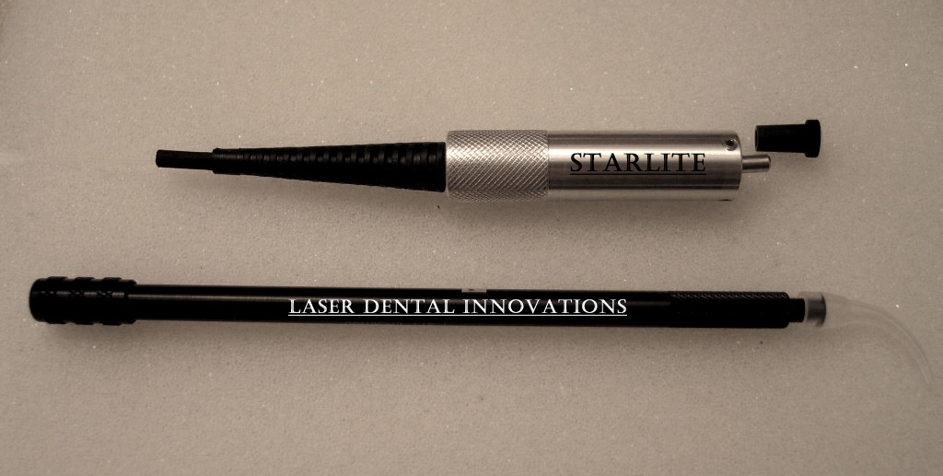
Protective
Cap
Fiber Strain
Relief
Laser Coupler

Using the Star Lite Fiber Optic:

Caution: Be careful to protect the front face of the optical ferrule at all times. Use protective cap when removed from the Laser. Distal end already has a tested good cleave for your convenience.
Cleaver Tip
- Sterilize the entire fiber optic assembly before use. (See sterilization instructions)
- Remove from autoclave pouch.
- Remove protective ferrule cover.
- Carefully insert into the laser port and fully tighten.
- Strip and cleave distal end of fiber and insert thru your handpiece and tip.

Note: The fiber optic has an outer larger Teflon Jacket that is split into 2 pieces each 5 feet long which assists in making sure the fiber will wind nicely.

When the handpiece gets close to the jacket simply pull one of the sections off and with scissors cut off 10 inches or so and slide the jacket back on.

When you get to the second section of fiber it can safely be pulled out of the rubber boot and inserted back afterwards.

Following the below procedure will result in a sterilization assurance level of 10⁻⁶ as verified by Northview Labs of Illinois

- Lightly wipe front ferrule surface with a lint free non abrasive cloth and IPA.
- Add protective front cap. If cap is lost be careful of front optical surface.
- Put in a large autoclave pouch that will allow maximum fiber coiling diameter. Coil diameter must be at least 6 inches.
- Avoid Ultrasonic Cleaning which may damage the front optical surface
- Autoclave at 270 F for 30 minutes
- Cool for 20 minutes before handling

